Lab Exercise 4

[Based on Python data types, conditional statements & Loops]

Q1: Write a python program to add all the odd numbers from 0 to 20.

Q 2: Write a python program to find the sum of all integers greater than 100 and less than 200.

Q3: Write a program to display the sum of square of the first ten even natural numbers

Q4: Write a python program to display ascii characters from 65 to 90
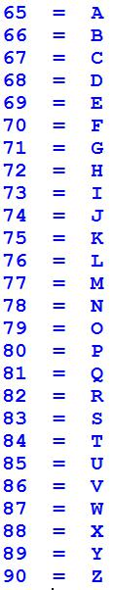

Q5: Display ascii characters from 48 to 57.

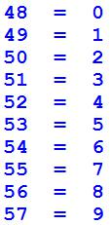

Q6: Display the following output with the help of Ascii character.
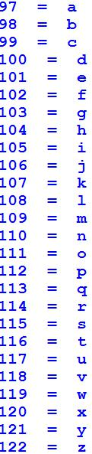

Q7: Write a python program for given a Python list you should be able to display Python list in the following order

L1 = [100, 200, 300, 400, 500]

Expected output:

[500, 400, 300, 200, 100]

Q8: Given a Python list. Write a python program to turn every item of a list into its square List1 = [1, 2, 3, 4, 5, 6, 7]

Expected output:

[1, 4, 9, 16, 25, 36, 49]

Q9: Program to count the number of each vowel in a string.

Q10: write a Program to sort alphabetically the words form a string provided by the user.
[You can use split() method to split string into a list of words. ]

Q 11: write a Program to Remove Punctuations from a String provided by the user. [Hint: use punctuation attribute of string module to get all punctuations (i.e. !"#$%&\'()*+,-./:;<=>?@[\\]^_`{|}~ ) ]

[Nested Loops]

Q12: Write a python program to print the Following:

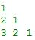

Q13: WAP to print the following asterisk pattern:

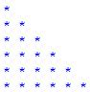

Q14: WAP to create a function traiangle to print the following asterisk triangle pattern:

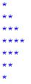

Q15: Write a python program to print following multiplication table on the screen

